**Step 1: Installing Geth on Ubuntu**

sudo apt update

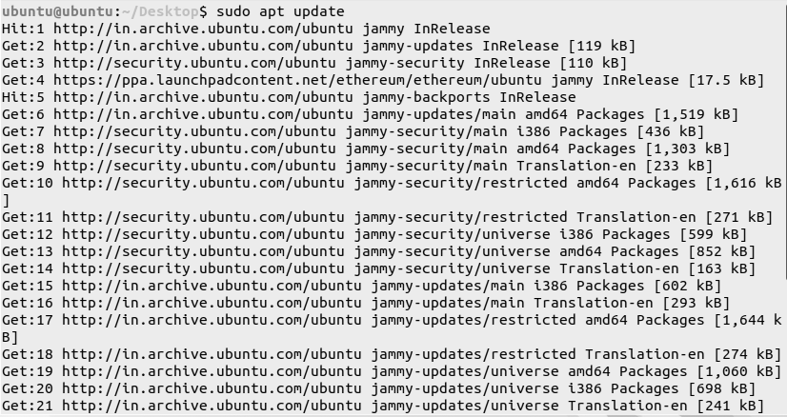

Sudo dpkg –configure -a



sudo apt install software-properties-common

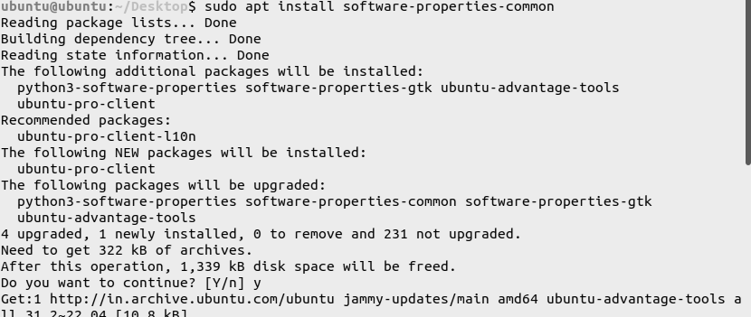

sudo add-apt-repository -y ppa:ethereum/ethereum

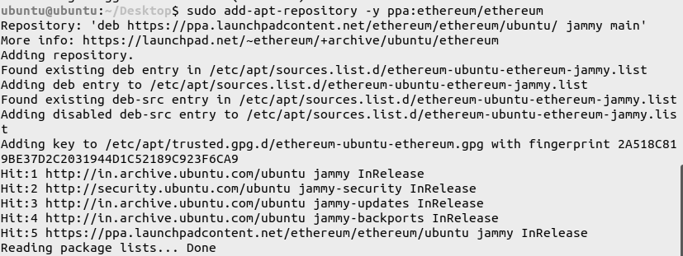

sudo apt update

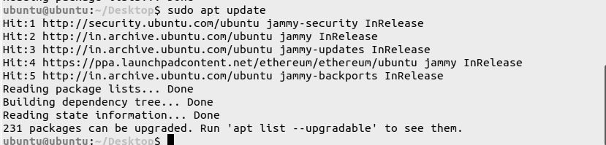

sudo apt install geth

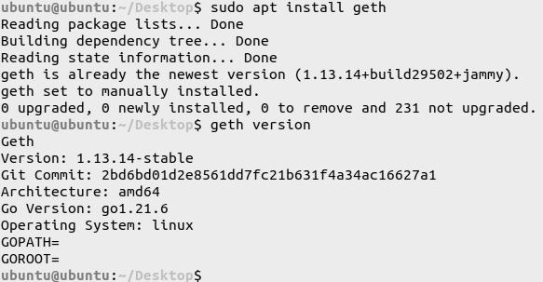

**Step 2: Check the version of Geth on the Terminal**

geth version



**3. Step - 3: Create a Private Ethereum Network**

1. Create a folder named, private_ethereum_setup



2. Create 2 subfolders named node1 and node2 in the folder private_ethereum_setup



3. Create 2 accounts in the folder corresponding to node1 and node2

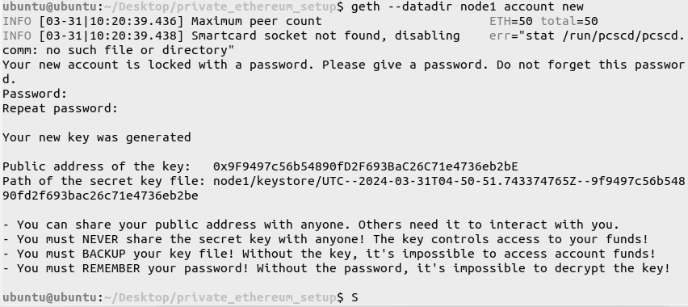

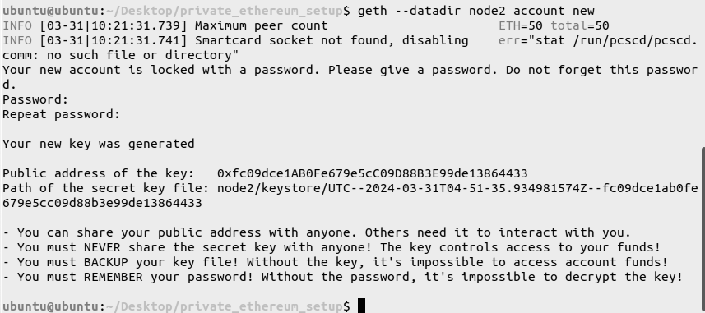

4. Create a genesis.json file in the folder, private_ethereum_setup

nano genesis.json

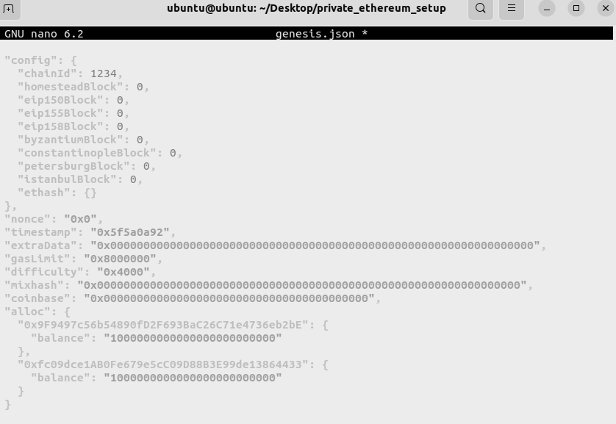

5. Initialize the nodes with the genesis file

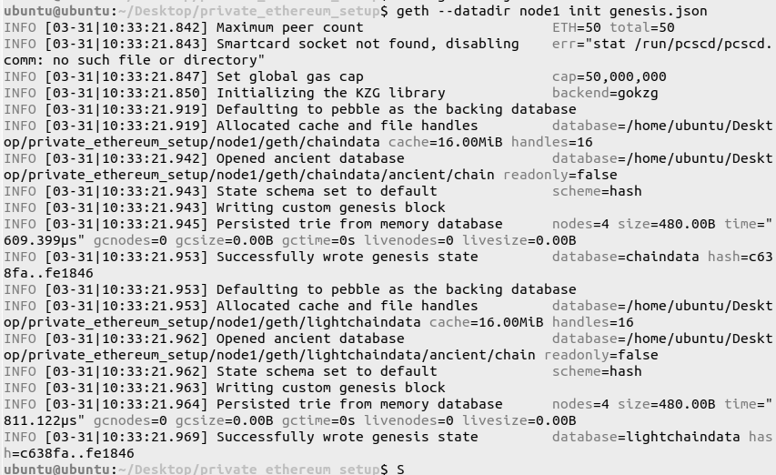

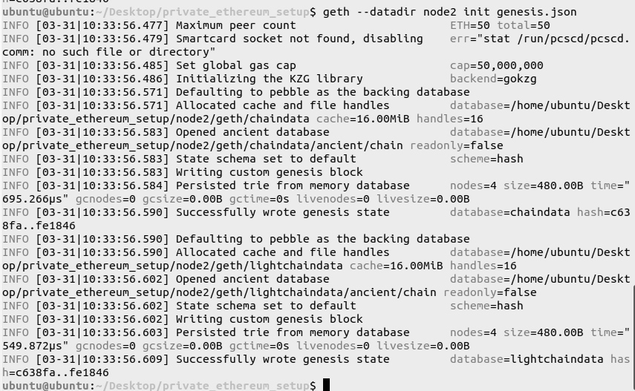

6. For configuring the boot node

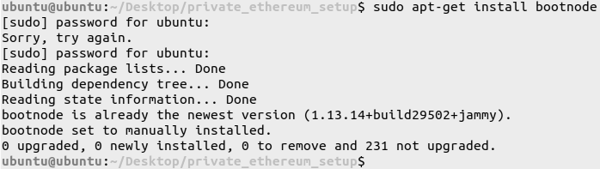

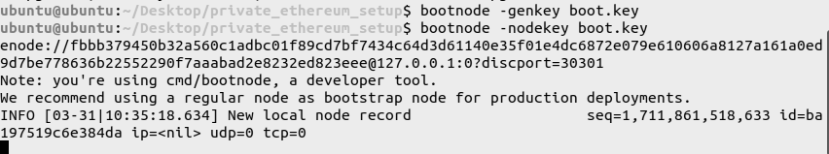

4. Step - 4: Establish a Peer-Peer Connection between the nodes along with the bootnode

1. On the first Terminal, Use boot.key to run the boot node

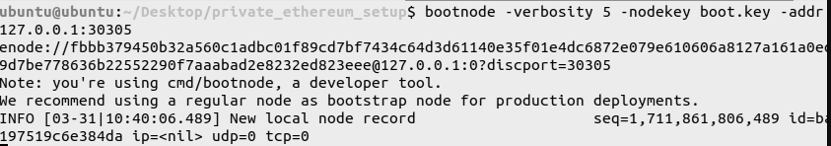

2. On the second Terminal, Run Node 1

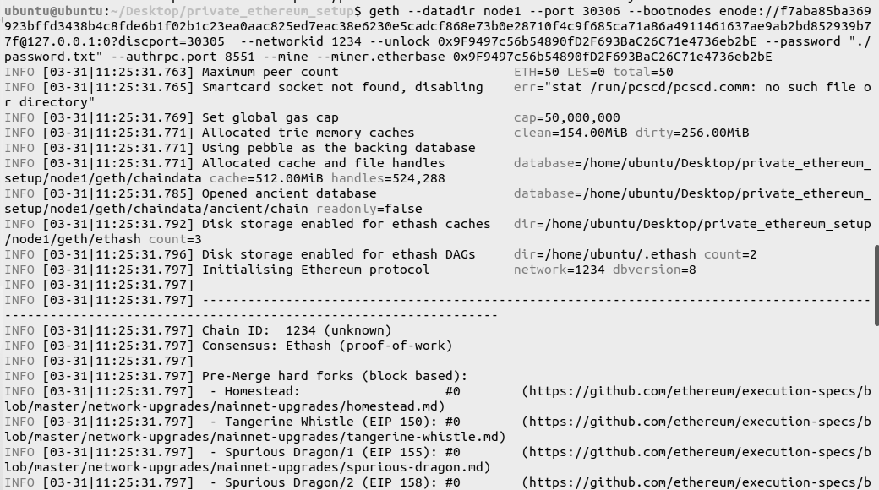

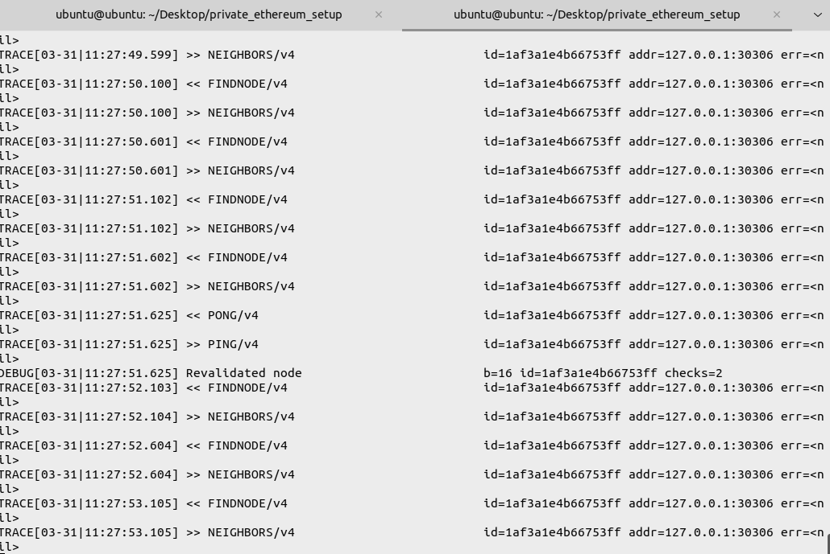

3. On the third Terminal, Run Node 2

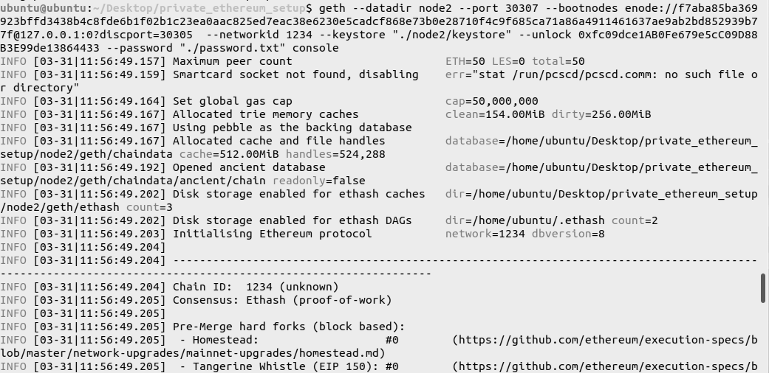



5. Step - 5 : Exploring the network by attaching JavaScript console to Node 1

1. Fetch network status

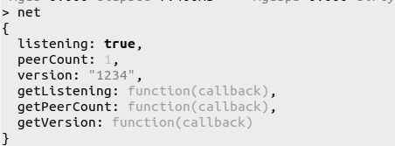

2. To fetch the number of blocks mined

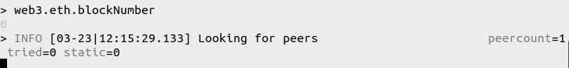

3. To check the balance of the accounts

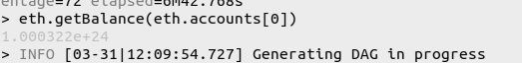

4. To fetch the details of the latest mined block

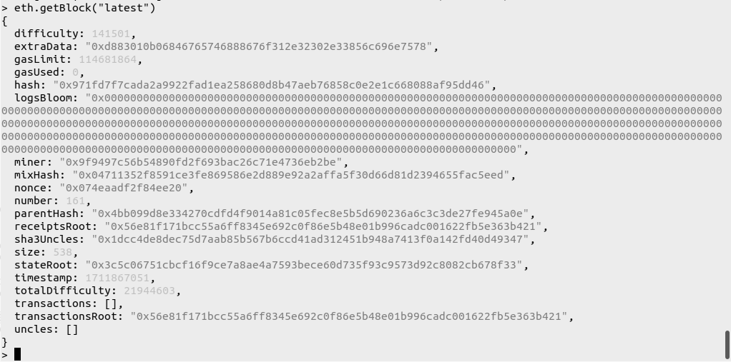

5. To fetch the details of a specific block

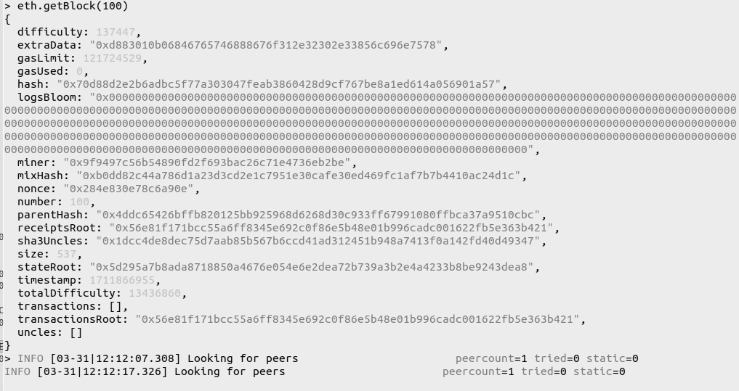

6. To check the account balance of the peer machine, provide their Public Key



7. Fetch the details of the peers in the network

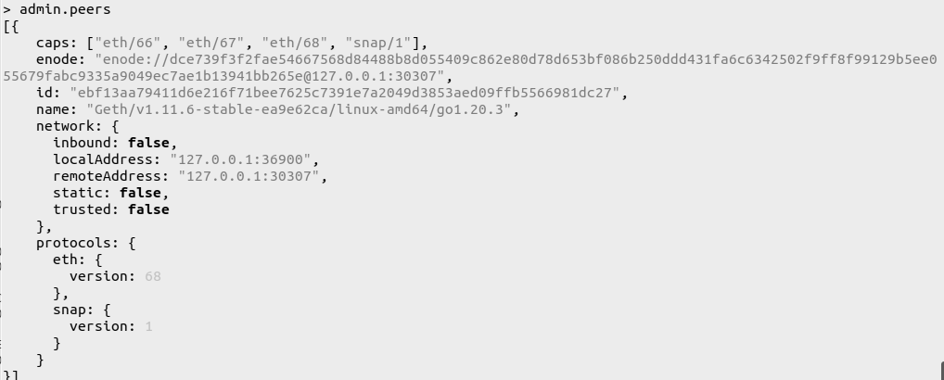

8. Perform Transactions between peers in the network

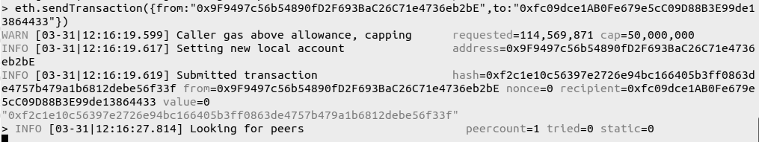

9. Check the balances of sender and receiver 2



10. To check the details of the transaction on Node 1 Terminal

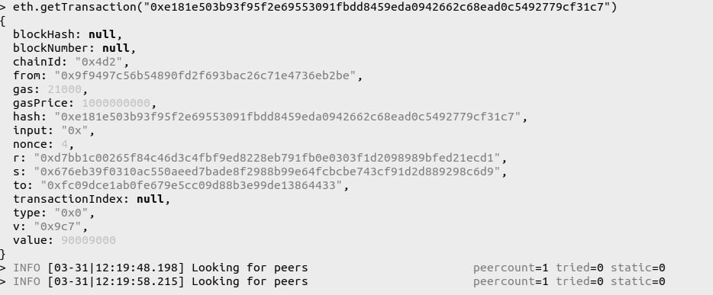

11. To check the contents in the Mempool - Transaction Pool

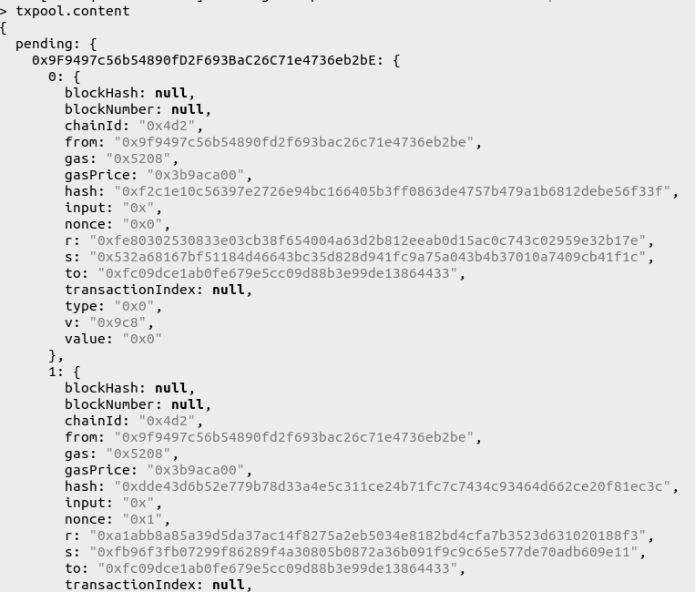

12. To check the status of the Mempool - Transaction Pool

